|  |  |
| --- | --- |
| **Total Marks:** | **7.5** |
| **Obtained Marks:** |  |

**DATA STRUCTURE**

**AND**

**ALGORITHM**

**Lab Report # 11**

**Submitted To: Mam Tehreem**

**_____________________________________________________________________________________________________________________________________________________________________________________________________________________________________**

**Submitted By**: **Hammad Qureshi**  .

**Reg. Numbers: 2112114**

**______________________________________________________________________________________________________________________________________________________________________________________________________________________________________**

**Question no 1:**

**Heap (Max-Heap, Min-Heap, Insertion and Deletion)**

**Code:**

|  |
| --- |
| **Max Heap**  #include <iostream>  using namespace std;  void max_heap(int *a, int m, int n) {  int j, t;  t = a[m];  j = 2 * m;  while (j <= n) {  if (j < n && a[j+1] > a[j])  j = j + 1;  if (t > a[j])  break;  else if (t <= a[j]) {  a[j / 2] = a[j];  j = 2 * j;  }  }  a[j/2] = t;  return;  }  void build_maxheap(int *a,int n) {  int k;  for(k = n/2; k >= 1; k--) {  max_heap(a,k,n);  }  }  int main() {  int n, i;  cout<<"enter no of elements of array\n";  cin>>n;  int a[30];  for (i = 1; i <= n; i++) {  cout<<"enter elements"<<" "<<(i)<<endl;  cin>>a[i];  }  build_maxheap(a,n);  cout<<"Max Heap\n";  for (i = 1; i <= n; i++) {  cout<<a[i]<<endl;  }  }  **Min heap**  #include <iostream>  #include <conio.h>  using namespace std;  void min_heap(int *a, int m, int n){  int j, t;  t= a[m];  j = 2 * m;  while (j <= n) {  if (j < n && a[j+1] < a[j])  j = j + 1;  if (t < a[j])  break;  else if (t >= a[j]) {  a[j/2] = a[j];  j = 2 * j;  }  }  a[j/2] = t;  return;  }  void build_minheap(int *a, int n) {  int k;  for(k = n/2; k >= 1; k--) {  min_heap(a,k,n);  }  }  int main() {  int n, i;  cout<<"enter no of elements of array\n";  cin>>n;  int a[30];  for (i = 1; i <= n; i++) {  cout<<"enter element"<<" "<<(i)<<endl;  cin>>a[i];  }  build_minheap(a, n);  cout<<"Min Heap\n";  for (i = 1; i <= n; i++) {  cout<<a[i]<<endl;  }  getch();  }  **Insertion**  #include <iostream>  using namespace std;    #define MAX 1000 // Max size of Heap    // Function to heapify ith node in a Heap  // of size n following a Bottom-up approach  void heapify(int arr[], int n, int i)  {  // Find parent  int parent = (i - 1) / 2;    if (arr[parent] > 0) {  // For Max-Heap  // If current node is greater than its parent  // Swap both of them and call heapify again  // for the parent  if (arr[i] > arr[parent]) {  swap(arr[i], arr[parent]);    // Recursively heapify the parent node  heapify(arr, n, parent);  }  }  }    // Function to insert a new node to the Heap  void insertNode(int arr[], int& n, int Key)  {  // Increase the size of Heap by 1  n = n + 1;    // Insert the element at end of Heap  arr[n - 1] = Key;    // Heapify the new node following a  // Bottom-up approach  heapify(arr, n, n - 1);  }    // A utility function to print array of size n  void printArray(int arr[], int n)  {  for (int i = 0; i < n; ++i)  cout << arr[i] << " ";    cout << "\n";  }    // Driver Code  int main()  {  // Array representation of Max-Heap  // 10  // / \  // 5 3  // / \  // 2 4  int arr[MAX] = { 10, 5, 3, 2, 4 };    int n = 5;    int key = 15;    insertNode(arr, n, key);    printArray(arr, n);  // Final Heap will be:  // 15  // / \  // 5 10  // / \ /  // 2 4 3  return 0;  }  **Deletion**  #include <iostream>    using namespace std;    // To heapify a subtree rooted with node i which is  // an index of arr[] and n is the size of heap  void heapify(int arr[], int n, int i)  {  int largest = i; // Initialize largest as root  int l = 2 * i + 1; // left = 2*i + 1  int r = 2 * i + 2; // right = 2*i + 2    // If left child is larger than root  if (l < n && arr[l] > arr[largest])  largest = l;    // If right child is larger than largest so far  if (r < n && arr[r] > arr[largest])  largest = r;    // If largest is not root  if (largest != i) {  swap(arr[i], arr[largest]);    // Recursively heapify the affected sub-tree  heapify(arr, n, largest);  }  }    // Function to delete the root from Heap  void deleteRoot(int arr[], int& n)  {  // Get the last element  int lastElement = arr[n - 1];    // Replace root with last element  arr[0] = lastElement;    // Decrease size of heap by 1  n = n - 1;    // heapify the root node  heapify(arr, n, 0);  }    /* A utility function to print array of size n */  void printArray(int arr[], int n)  {  for (int i = 0; i < n; ++i)  cout << arr[i] << " ";  cout << "\n";  }    // Driver Code  int main()  {  // Array representation of Max-Heap  // 10  // / \  // 5 3  // / \  // 2 4  int arr[] = { 10, 5, 3, 2, 4 };    int n = sizeof(arr) / sizeof(arr[0]);    deleteRoot(arr, n);    printArray(arr, n);    return 0;  } |

**CONSOLE SCREEN:**

**Max heap**

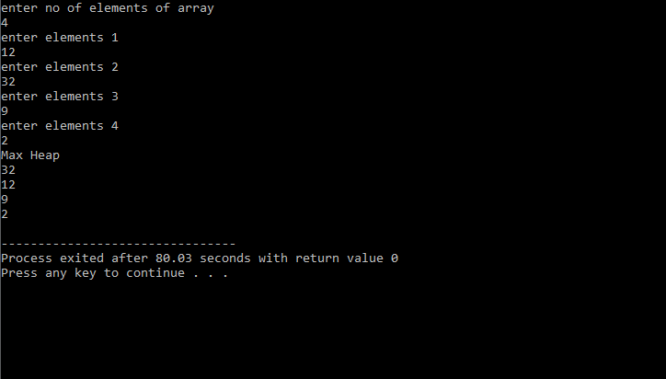

**Min heap**

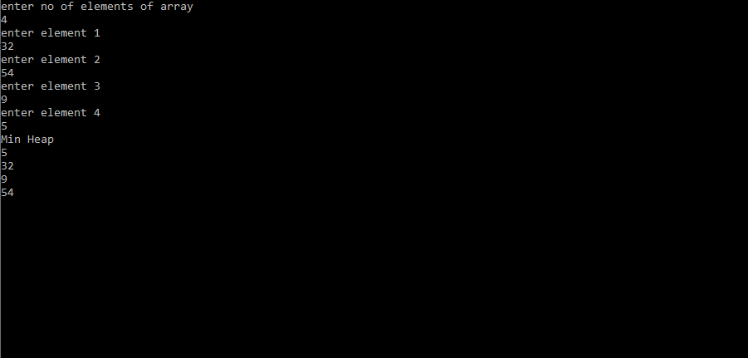

**Insertion**

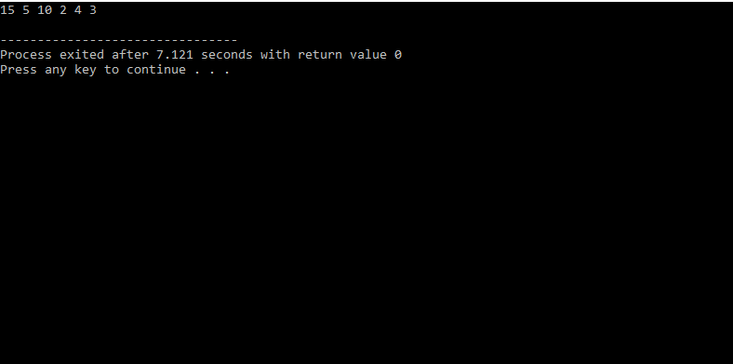

**Deletion**

